**EAST WEST UNIVERSITY**

**LAB – 2**

**Newton Raphson & Secant Method**

**Course Code: ICE470**

**Course Title: Applied Numerical Methods**

**Section – 01**

**Submitted To:**

Muhammad Suhail Najeeb  
Lecturer

Dept. of ECE

East West University

**Submitted By:**

MD Imran Ahmed

ID: 2015-2-50-018

**Date of Submission**: 17-06-2019

**Objective:**

Applying Newton-Raphson & Secant method to obtain the root of the function

F(x) = cos(x) – 3x + 1

**Newton-Raphson function:**

function r = newton(f,df,x0,es,imax)

xr = x0;

ea = 10000;

iter =0;

fprintf('it \t \t xr \t f(xr) \t\t error \n');

while(ea> es &&iter<imax)

xrold = xr;

F = feval(f,xrold);

DF = feval(df,xrold);

xr = xrold - F/DF;

iter = iter +1;

if(xr ~= 0)

ea = abs((xr - xrold) / xr) *100;

end

fprintf('%d \t %f \t %f \t %f \n', iter,xr,F,ea);

end

r = xr;

end

**Plot Newton-Raphson:** for the this function F(x) = cos(x) – 3x + 1

f = @(x) cos(x) - 3*x +1;

df = @(x) -sin(x) - 3;

x = 0:0.01:0.5*pi;

y = feval(f,x);

plot(x,y);

xlabel('x');

ylabel('y');

grid on;

x0 = 1;

%xu = 0;

es = 0.001;

imax = 10;

r = newton(f,df,x0,es,imax);

disp(r);

**Output:**

>>plot_newton

it xr f(xr) error

1 0.620016 -1.459698 61.286173

2 0.607121 -0.046179 2.124008

3 0.607102 -0.000068 0.003131

4 0.607102 -0.000000 0.000000

0.6071

**Figure:**

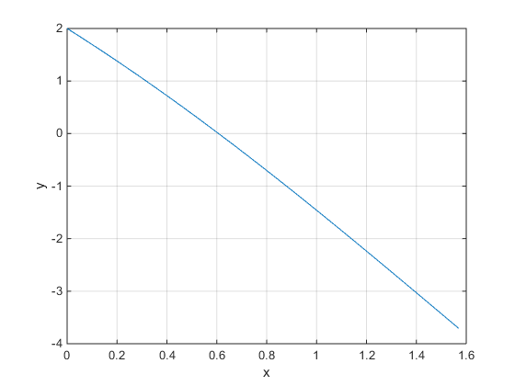

**Secant function:**

function r = secant(f,x,es,imax)

xr = x;

ea = 10000;

iter =0;

x0 = 0;

fprintf('iteration \t \t xr \t f(xr) \t\t error \n');

while(ea> es &&iter<imax)

xrold = xr;

fx0 = feval(f,x0);

fx = feval(f,xrold);

xr = xrold - (fx * (x0 - xrold)) / (fx0 - fx);

iter = iter +1;

if(xr ~= 0)

ea = abs((xr - xrold) / xr) *100;

end

fprintf('%d \t %f \t %f \t %f \n', iter,xr,fx,ea);

end

r = xr;

end

**Plot the function using secant method:**

F(x) = cos(x) + 2sin(x) + x

f = @(x) cos(x) +2*sin(x) + x;

x = 0:0.01:0.5*pi;

y = feval(f,x);

plot(x,y);

xlabel('x');

ylabel('y');

grid on;

es = 0.001;

imax = 10;

x = 1;

r = secant(f,x,es,imax);

**Output:**

disp(r);

>>plot_secant

iteration xr f(xr) error

1 -0.449793 3.223244 322.324428

2 -0.317020 -0.418815 41.881456

3 -0.320117 0.009675 0.967450

4 -0.320029 -0.000275 0.027477

5 -0.320032 0.000008 0.000777

-0.3200

**Figure:**

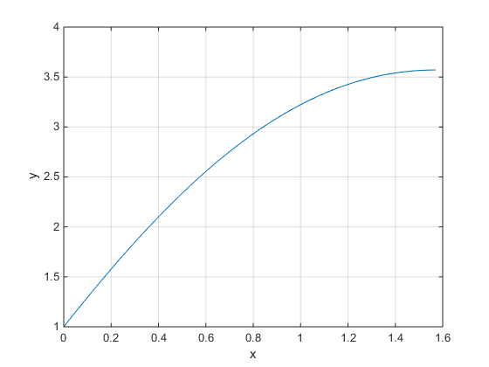

**Discussion:**

Newton-Raphson and secant method is the open method approach to find the root of any function. We calculated the derivative of the given function. Which actually slope of that function. And then gradually we converged into the minimal root.

Bellow are the root of two given function.

F(x) = cos(x) – 3x + 1

Xr = 0.6071

F(x) = cos(x) + 2sin(x) + x

Xr = -0.3200